# LED water lamp experiment

## Introduction to LED Devices

LED, short for light-emitting diode, is made by mixed compounds which are gallium (Ga), arsenic (AS), phosphorus (P). Phosphorus gallium arsenide diode glows red, gallium phosphide diode glows green, silicon carbide diode glows yellow.

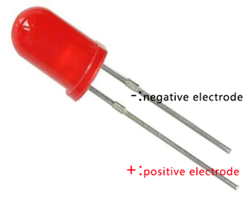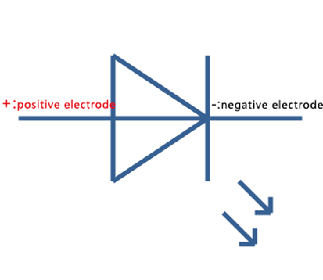

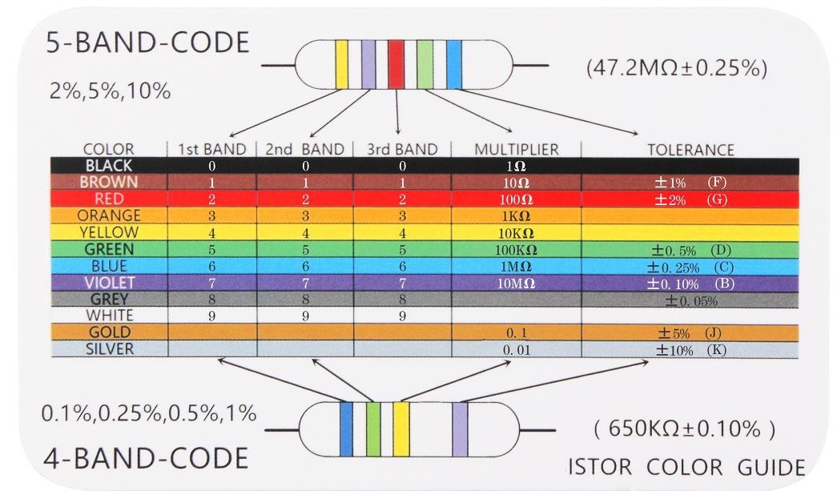

Color ring resistors are the most commonly used electronic components in electronic circuits. Color ring resistors are color rings coated with different colors on ordinary resistor packages to distinguish the resistance of the resistor.

The commonly used color ring resistance can be divided into four rings and five rings, usually four rings. Among them, the first two rings of the four-ring resistance are numbers, the third ring represents the number multiplied by the resistance value, and the last ring is the error; the first three rings of the five-ring resistance are numbers, the fourth ring represents the number multiplied by the resistance, and the last ring Is the error.

For example: the first ring of a resistor is red (representing 2), the second ring is purple (representing 7), the third ring is brown (representing 10 times), and the fourth ring is gold (representing ±5%), then this The resistance of the resistor should be 270Ω, and the error range of the resistance is ±5%.工作原理

The reverse breakdown voltage of the light-emitting diode is 5v. The positive volt-ampere characteristic curve is too steep and must be connected in series with a current limiting resistor in order to control the current flowing through the pipeline when in use. The current limiting resistor R can be obtained by the following formula:



In the formula, E stands for power voltage, VF is forward voltage drop of LED，I shows

the general working current of LED. The working voltage of light-emitting diodes are generally from 1.5 V to 2.0 V, the working current is usually 10 ~ 20 mA. So in the digital logic circuit of 5v, We can use 220Ω resistor as a current limiting resistor.

## Experiment Purpose

What is a running light ? We heard of running mountain stream, running river , etc. Just as its name implies, making lights light up like running water. Our purpose is to achieve the effect of a single light glows from left to right, then all the lights glow from left to right and this cycle continues.

## 组件清单

* RaspberryPi 主板
* T type expansion board
* Breadboard
* power cable
* LED * 6
* 1k Resistors *6
* Several jumper wires

## 接线

|  |  |
| --- | --- |
| RaspberryPi | LED |
| IO2(wiringPi)\22(BCM) | 1 |
| IO3(wiringPi)\23(BCM) | 2 |
| IO4(wiringPi)\24(BCM) | 3 |
| IO5(wiringPi)\25(BCM) | 4 |
| IO6(wiringPi)\26(BCM) | 5 |
| IO25(wiringPi)\27(BCM) | 6 |
| GND | GND |

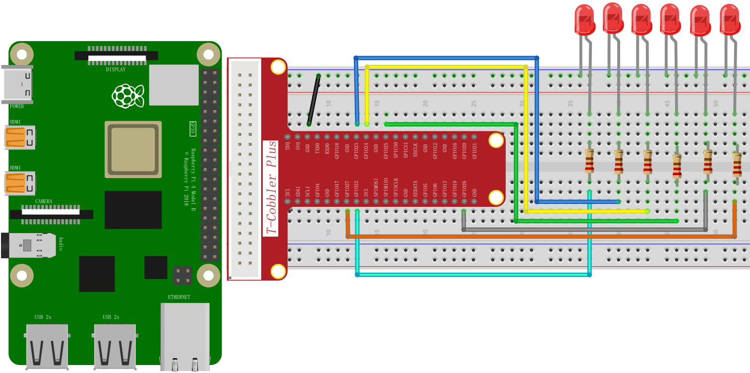

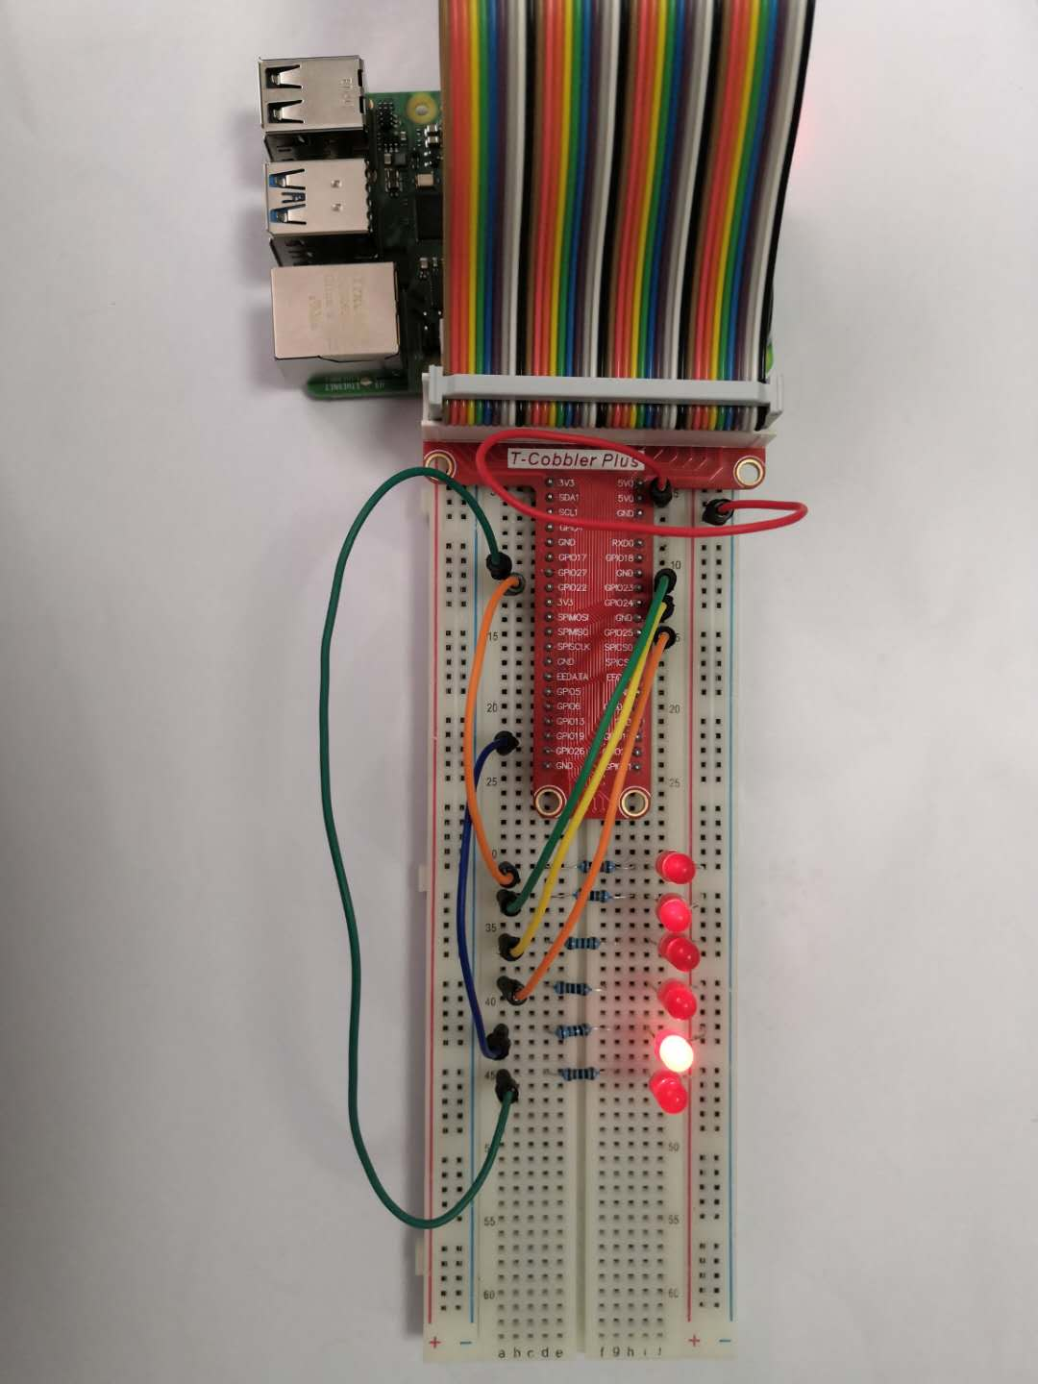

## 程序原理

First, we set IO2-IO6 and IO25 (wiringPi code) or 22-27 (BCM code) pins to high level, that is, the initial state of all LEDs is off, and then switch the digital 22 pin to low level , So the leftmost LED lights up. After a delay of 500ms, we set pins 23-27 to low level, and other pins keep high level, so that each LED turns on for 500ms in the first round. In the second round, we set pin 22 to low level, the first LED lights up, and then all the LEDs are placed low level from left to right, now all lights are on, and this cycle continues. Its effect looks like "tap water". If you want the LED to flash quickly, you can reduce the delay time, but if the delay time is too short, it seems that all the LEDs in our eyes are always on; if you want the LED to flash slowly, you can extend the delay time, but if the time delay is too short Long, you may not see the flickering effect.

## C++ program

|  |
| --- |
| #include <stdio.h>  #include <wiringPi.h>  using namespace std**;**  int main **()**  **{**  wiringPiSetup**();**  pinMode**(**3**,** OUTPUT**);**  pinMode**(**4**,** OUTPUT**);**  pinMode**(**5**,** OUTPUT**);**  pinMode**(**6**,** OUTPUT**);**  pinMode**(**25**,** OUTPUT**);**  pinMode**(**2**,** OUTPUT**);**  **while(**1**)**  **{**  digitalWrite**(**3**,** HIGH**);**  delay**(**500**);**  digitalWrite**(**3**,** LOW**);**  digitalWrite**(**4**,** HIGH**);**  delay**(**500**);**  digitalWrite**(**4**,** LOW**);**  digitalWrite**(**5**,** HIGH**);**  delay**(**500**);**  digitalWrite**(**5**,** LOW**);**  digitalWrite**(**6**,** HIGH**);**  delay**(**500**);**  digitalWrite**(**6**,** LOW**);**  digitalWrite**(**25**,** HIGH**);**  delay**(**500**);**  digitalWrite**(**25**,** LOW**);**  digitalWrite**(**2**,** HIGH**);**  delay**(**500**);**  digitalWrite**(**2**,** LOW**);**  **}**    **}** |

## Python program

|  |
| --- |
| import RPi**.**GPIO as GPIO  import time  GPIO**.**setmode**(**GPIO**.**BCM**)**  GPIO**.**setup**(**22**,** GPIO**.**OUT**)**  GPIO**.**setup**(**23**,** GPIO**.**OUT**)**  GPIO**.**setup**(**24**,** GPIO**.**OUT**)**  GPIO**.**setup**(**25**,** GPIO**.**OUT**)**  GPIO**.**setup**(**26**,** GPIO**.**OUT**)**  GPIO**.**setup**(**27**,** GPIO**.**OUT**)**  **while** True**:**  GPIO**.**output**(**22**,** GPIO**.**HIGH**)**  time**.**sleep**(**0.5**)**  GPIO**.**output**(**22**,** GPIO**.**LOW**)**  time**.**sleep**(**0.5**)**  GPIO**.**output**(**23**,** GPIO**.**HIGH**)**  time**.**sleep**(**0.5**)**  GPIO**.**output**(**23**,** GPIO**.**LOW**)**  time**.**sleep**(**0.5**)**  GPIO**.**output**(**24**,** GPIO**.**HIGH**)**  time**.**sleep**(**0.5**)**  GPIO**.**output**(**24**,** GPIO**.**LOW**)**  time**.**sleep**(**0.5**)**  GPIO**.**output**(**25**,** GPIO**.**HIGH**)**  time**.**sleep**(**0.5**)**  GPIO**.**output**(**25**,** GPIO**.**LOW**)**  time**.**sleep**(**0.5**)**  GPIO**.**output**(**26**,** GPIO**.**HIGH**)**  time**.**sleep**(**0.5**)**  GPIO**.**output**(**26**,** GPIO**.**LOW**)**  time**.**sleep**(**0.5**)**  GPIO**.**output**(**27**,** GPIO**.**HIGH**)**  time**.**sleep**(**0.5**)**  GPIO**.**output**(**27**,** GPIO**.**LOW**)**  time**.**sleep**(**0.5**)**  GPIO**.**clearnup**()** |

## Java program

|  |
| --- |
| **import** com**.**pi4j**.**io**.**gpio**.**GpioController**;**  **import** com**.**pi4j**.**io**.**gpio**.**GpioFactory**;**  **import** com**.**pi4j**.**io**.**gpio**.**GpioPinDigitalOutput**;**  **import** com**.**pi4j**.**io**.**gpio**.**PinState**;**  **import** com**.**pi4j**.**io**.**gpio**.**RaspiPin**;**  public class Led_running **{**    public static void main**(**String**[]** args**)** **throws** InterruptedException **{**    // create gpio controller  final GpioController gpio **=** GpioFactory**.**getInstance**();**    // provision gpio pin as an output pin and turn on  final GpioPinDigitalOutput pin1 **=** gpio**.**provisionDigitalOutputPin**(**RaspiPin**.**GPIO_03**,** "MyLED"**,** PinState**.**HIGH**);**  final GpioPinDigitalOutput pin2 **=** gpio**.**provisionDigitalOutputPin**(**RaspiPin**.**GPIO_04**,** "MyLED"**,** PinState**.**HIGH**);**  final GpioPinDigitalOutput pin3 **=** gpio**.**provisionDigitalOutputPin**(**RaspiPin**.**GPIO_05**,** "MyLED"**,** PinState**.**HIGH**);**  final GpioPinDigitalOutput pin4 **=** gpio**.**provisionDigitalOutputPin**(**RaspiPin**.**GPIO_06**,** "MyLED"**,** PinState**.**HIGH**);**  final GpioPinDigitalOutput pin5 **=** gpio**.**provisionDigitalOutputPin**(**RaspiPin**.**GPIO_25**,** "MyLED"**,** PinState**.**HIGH**);**    Thread**.**sleep**(**5000**);**  **for** **(** **;** **;** **)** **{**  pin1**.**toggle**();**  System**.**out**.**println**(**"--> GPIO state should be: ON"**);**  Thread**.**sleep**(**1000**);**  pin1**.**toggle**();**  System**.**out**.**println**(**"--> GPIO state should be: OFF"**);**  Thread**.**sleep**(**1000**);**  pin2**.**toggle**();**  System**.**out**.**println**(**"--> GPIO state should be: ON"**);**  Thread**.**sleep**(**1000**);**  pin2**.**toggle**();**  System**.**out**.**println**(**"--> GPIO state should be: OFF"**);**  Thread**.**sleep**(**1000**);**  pin3**.**toggle**();**  System**.**out**.**println**(**"--> GPIO state should be: ON"**);**  Thread**.**sleep**(**1000**);**  pin3**.**toggle**();**  System**.**out**.**println**(**"--> GPIO state should be: OFF"**);**  Thread**.**sleep**(**1000**);**  pin4**.**toggle**();**  System**.**out**.**println**(**"--> GPIO state should be: ON"**);**  Thread**.**sleep**(**1000**);**  pin4**.**toggle**();**  System**.**out**.**println**(**"--> GPIO state should be: OFF"**);**  Thread**.**sleep**(**1000**);**  pin5**.**toggle**();**  System**.**out**.**println**(**"--> GPIO state should be: ON"**);**  Thread**.**sleep**(**1000**);**  pin5**.**toggle**();**  System**.**out**.**println**(**"--> GPIO state should be: OFF"**);**  Thread**.**sleep**(**1000**);**  **}**  **}**  **}** |

## 实验结果

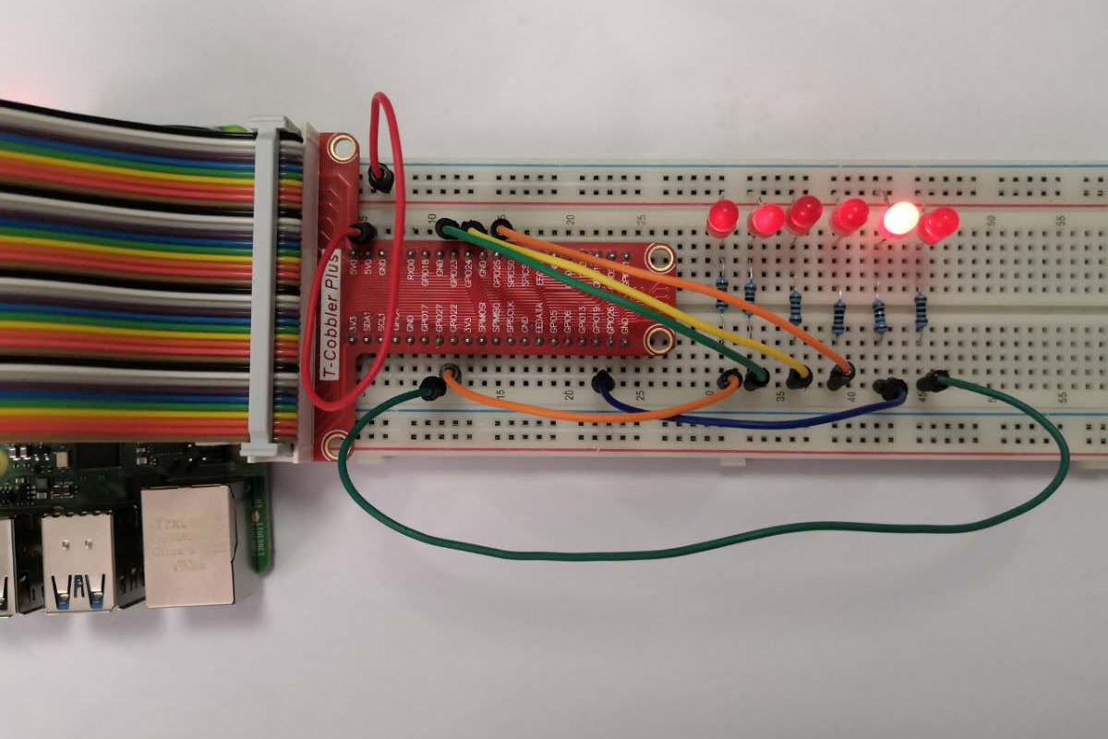

The LED lights turn on sequentially from left to right and then turn off, lighting up in cycles.